Historical Investigation — Impact of the Movement of Peoples in History


Directions: In order to answer the focus question, you must first consider the source, purpose, and content of each historical document. You must also consider how the content of each document corroborates (supports) or contradicts evidence found in other documents. Examine all the documents then answer the questions that follow. This will assist you in answering the focus question at the end of the investigation.

Focus Question: How did the movement of people result in political, economic, and cultural changes?

Document 1: Major Languages of Central and South Africa
This document was created using information from a website about African languages. It shows some of the most commonly spoken languages in Central and South Africa.

Language | Countries Spoken | Number of People who Speak This Language | Language Family
Swahili | Kenya, Tanzania, Congo, Uganda | 30 million | Bantu
Zulu | South Africa | 4 million | Bantu
Makua | Mozambique | 4 million | Bantu
Shona | Zimbabwe, Mozambique | 8 million | Bantu
Mbundu | Angola | 6 million | Bantu
Lingala | Congo | 6 million | Bantu
Source: http://encyclopedia2.thefreedictionary.com/Bantu+languages

- Identify the source and type of document.

- What conclusions can you draw from this data?

- Does this document corroborate (support) or contradict the others? Why or why not?

- How might the data in this chart help you answer the focus question?

Focus Question: How did the movement of people result in political, economic, and cultural changes?

Document 2: Images of Polynesian Dance Traditions on Different Polynesian Islands
These images show various styles of dance found on different islands inhabited by Polynesian people.

Hawaiian Fire Dancing  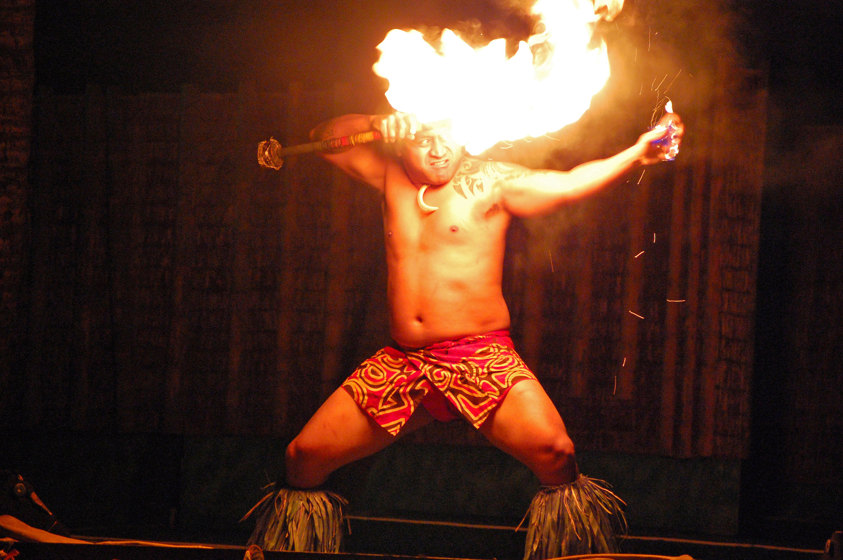 | Samoa Fire Dancing  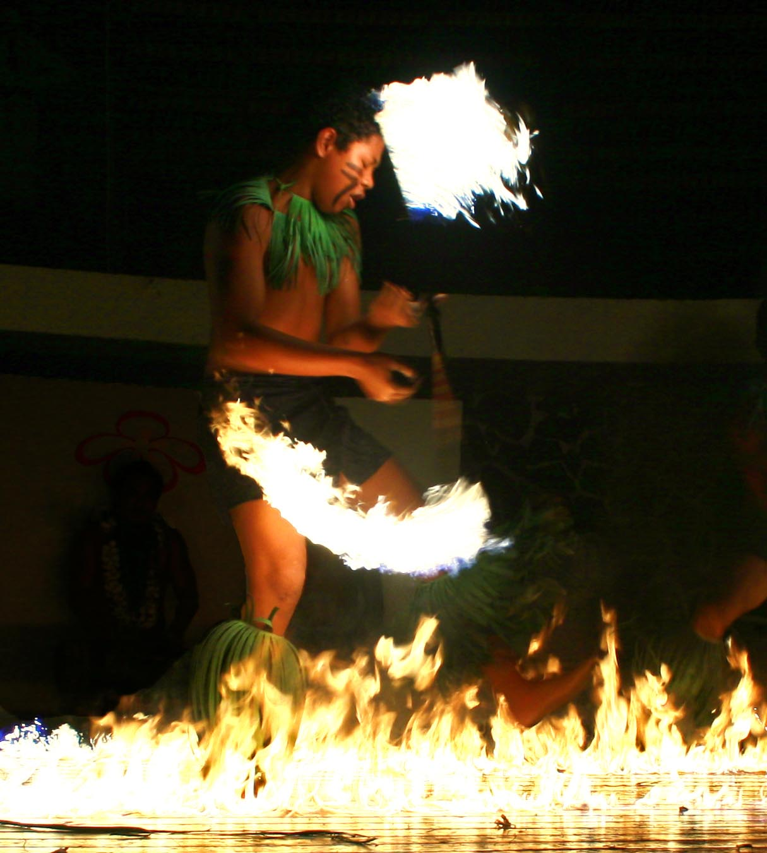
Cook Island Dancing | Hawaiian Festival Dancing
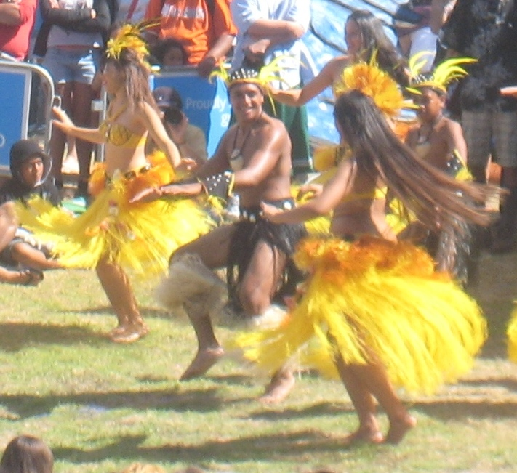 | 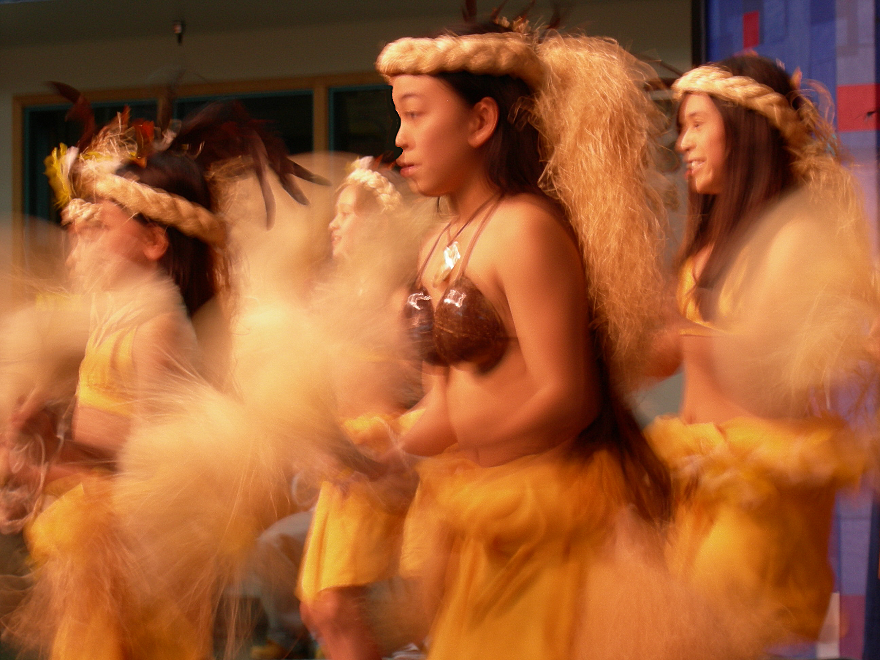
Sources: http://commons.wikimedia.org/wiki/File:Fire_dancer.JPG
http://commons.wikimedia.org/wiki/File:Samoa_fire_dance_-_siva_afi.jpg
http://commons.wikimedia.org/wiki/File:Cook_Islands_dancers_at_Auckland%27s_Pacifica_festival_3a.jpg
http://commons.wikimedia.org/wiki/File:Festal_Hawaiian_dancers_03.jpg

- Identify the source and type of document.

- What conclusions can you draw from these images?

- Does this document corroborate (support) or contradict the others? Why or why not?

- How might these images help you answer the focus question?

Focus Question: How did the movement of people result in political, economic, and cultural changes?

Document 3: Impact of the Vikings
The following excerpt came from an online textbook created by an Arizona school district.

As devastating as the Viking invasions themselves was the fear they created. For survival men of every class sought protectors, and it was during this age of insecurity that the primary institutions of feudalism--lordship and vassalage--were shaped… Protection of the vassal's person, his family, and lands was the lord's principal duty, along with granting him justice in a court of his peers… The vassal, in return, was obliged to make himself available, fully equipped, for service in the lord's army for a period conventionally set at forty days…

Source: http://edweb.tusd.k12.az.us/uhs/website/courses/WC/Milo%20Chpts/Ch%2010%20Feudal%20Age.htm

- Identify the source and type of document.

- What conclusions can you draw from this excerpt?

- Does this document corroborate (support) or contradict the others? Why or why not?

- How might this document help you answer the focus question?

Focus Question: How did the movement of people result in political, economic, and cultural changes?

Document 4: A Description of Baghdad, 1000 CE
This excerpt comes from a first-hand description of the city of Baghdad. Baghdad was established by the Abbasid Dynasty as they expanded into modern-day Iraq.
Baghdad was a veritable City of Palaces, not made of stucco and mortar, but of marble. The buildings were usually of several stories. The palaces and mansions were lavishly gilded and decorated, and hung with beautiful tapestry and hangings of brocade or silk. The rooms were lightly and tastefully furnished with luxurious divans, costly tables, unique Chinese vases and gold and silver ornaments.
Both sides of the river were for miles fronted by the palaces, kiosks, gardens and parks of the grandees and nobles, marble steps led down to the water's edge, and the scene on the river was animated by thousands of gondolas, decked with little flags, dancing like sunbeams on the water, and carrying the pleasure-seeking Baghdad citizens from one part of the city to the other. Along the wide-stretching quays lay whole fleets at anchor, sea and river craft of all kinds, from the Chinese junk to the old Assyrian raft resting on inflated skins.
The mosques of the city were at once vast in size and remarkably beautiful. There were also in Baghdad numerous colleges of learning, hospitals, infirmaries for both sexes, and lunatic asylums.
Source: http://www.fordham.edu/halsall/source/1000baghdad.html

- Identify the source and type of document.

- What conclusions can you draw from this excerpt?

- Does this document corroborate (support) or contradict the others? Why or why not?

- How might this document help you answer the focus question?

Focus Question: How did the movement of people result in political, economic, and cultural changes?

Document 5: Description of Magyars
This description of the Magyars is from San Jose State University’s history department website.

When the Magyars settled in the Hungarian plain they raided far and wide in Europe for about sixty years until finally defeated by the German king Otto I. The Magyars accepted Christianity in the late tenth century and led a more subdued existence thereafter. The cost of the Magyar raids to Europe were offset by the benefit that Europe gained from having a martial people as a buffer against the invasions of other martial peoples from Asia. The Mongols spent some of their fury on the Hungarians, saving western European territories from the full brunt of their onslaught in the 13th century. When the Turks came knocking on Europe's door in the 15th century it was the Hungarians who again slowed the invasion. The Hungarians were not victorious against the Turks but they did limit the Ottoman advance.

Source: http://www.sjsu.edu/faculty/watkins/hungary.htm

- Identify the source and type of document.

- What conclusions can you draw from this excerpt?

- Does this document corroborate (support) or contradict the others? Why or why not?

- How might this document help you answer the focus question?

Focus Question: How did the movement of people result in political, economic, and cultural changes?

Now, consider your responses to the questions as you viewed each document about the impact of the movement of humans in the pre-modern world.
- Identify the source and type of document.
- What conclusions can you draw from each document, image, or data?
- Does this document corroborate (support) or contradict the others? Why or why not?
- How might this document, image, or data help you answer the focus question?

Answer the following question based on your review of Documents 1 through 5.

How did the movement of people result in political, economic, and cultural changes?
- Think about how the movement of people impacted the world politically and economically.
- Think about how the movement of people resulted in cultural changes or diffusion.
- Include details and examples to support your answer.

