Historical Investigation — Africa’s Islamic Capital


Directions: In order to answer the focus question, you must first consider the source, purpose, and content of each historical document. You must also consider how the content of each document corroborates (strengthens) or contradicts evidence found in other documents. Examine all the documents and then answer the questions that follow. This will assist you in answering the focus question at the end of the investigation.

Background: Timbuktu (in present day Mali) has been a city of cultural diversity in West Africa for over a thousand years. During the Mali and Songhai Empires of the period 1300-1550, the city served as a destination for salt and gold traders on the trans-Saharan trade network, as well as Muslim scholars and students. The story of Timbuktu reflects the origins and cultural/political impacts of Islam on many other urban centers of Africa. Many believe Timbuktu’s thriving economy, culture, and support for education made it the early Islamic capital of Africa.

Focus Question: Why does Timbuktu deserve the title of the “Islamic Capital of Africa?”

Document 1: Trans-Saharan Trade Destination
Timbuktu (Tombouctou on the map below) was a center of trade in the Ghana, Mali, and Songhai empires of West Africa. Shown here are the trans-Saharan routes through the present day country of Niger (in gold). These routes of travel and trade carried Islamic scholars and literature to and from centers of the Muslim world.

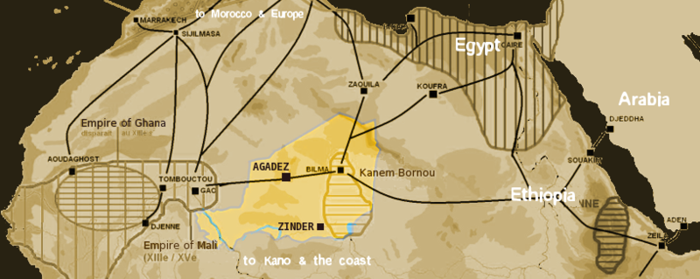
Source: This image from http://en.wikipedia.org/wiki/File:Niger_saharan_medieval_trade_routes.PNG is in the public domain.

- Identify the source and type of document.

- What is the message of the document?

- Does this document corroborate (support) or contradict the others? Why or why not?

- How might this document help you answer the focus question?

Focus Question: Why does Timbuktu deserve the title of the “Islamic Capital of Africa?”

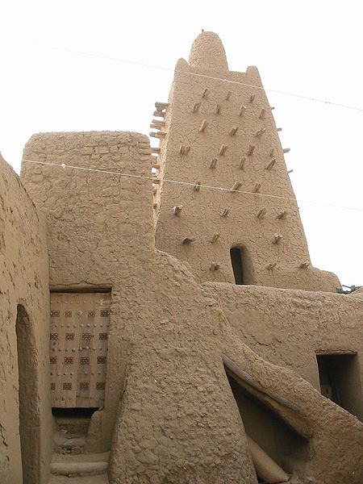
Document 2: A City of Islamic Learning
Upon Mali King Mansa Musa’s return from his holy pilgrimage, or “hajj”, to Mecca on the Arabian Peninsula, Mansa oversaw the construction of the Djinguereber Mosque in 1327, as seen here. The mosque served as one of many madrasas, sites where scholars teach the principles of Islamic faith, law and other topics found in present day schools.

Source: This image from http://en.wikipedia.org/wiki/File:Djingareiber_cour.jpg is licensed with Creative Commons Attribution. Attribution: KaTeznik.

- Identify the source and type of document.

- What is the message of the document?

- Does this document corroborate (support) or contradict the others? Why or why not?

- How might this document help you answer the focus question?

Focus Question: Why does Timbuktu deserve the title of the “Islamic Capital of Africa?”

Document 3: Making the Map of Europe
Timbuktu’s appearance in the Catalan atlas in 1375 was significant, considering the atlas’s wide distribution throughout Europe during the Medieval Era. The city’s appearance alongside the image of Mansa Musa in the lower left portion of the map below reflected the role of the city as a destination for long distance travel and trade. It would become known to Europeans as a center of trade and Islamic learning.

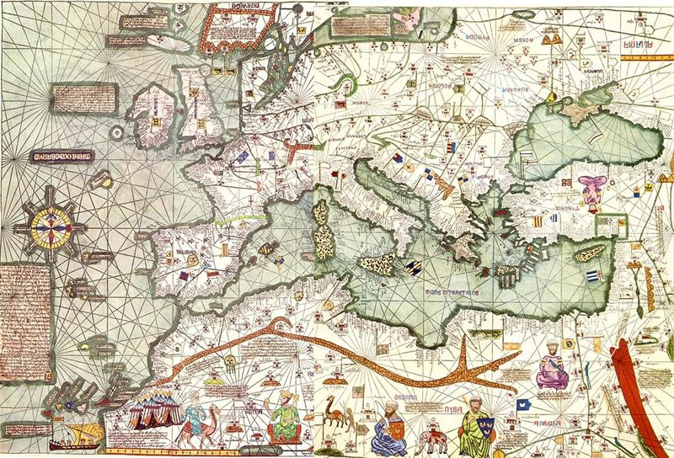

Timbuktu
Mansa Musa
Source: This image from http://en.wikipedia.org/wiki/File:Europe_Mediterranean_Catalan_Atlas.jpeg is in the public domain because its copyright has expired.
- Identify the source and type of document.

- What is the message of the document?

- Does this document corroborate (support) or contradict the others? Why or why not?

- How might this document help you answer the focus question?

Focus Question: Why does Timbuktu deserve the title of the “Islamic Capital of Africa?”

Document 4: The Timbuktu Manuscripts
Pre-modern history of Africa remains elusive due to the lack of recorded information, especially compared with cultures in Eurasia. Native Africans often depended on oral histories to pass down knowledge of the past to future generations. An exception to this are the manuscripts created for the Islamic madrasas of Timbuktu. These written archives contain valuable information on Islamic law, mathematics, and science. The page shown in the image here discusses principles of astronomy and mathematics.

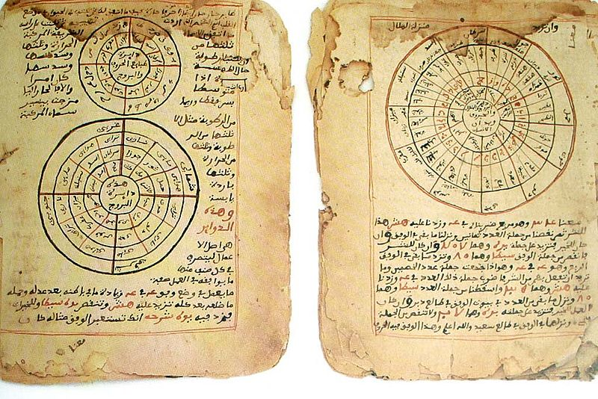
Source: This image from http://www.wdl.org/en/item/30/?ql=eng&s=timbuktu&view_type=gallery is in the public domain because its copyright has expired.

- Identify the source and type of document.

- What is the message of the document?

- Does this document corroborate (support) or contradict the others? Why or why not?

- How might this document help you answer the focus question?

Focus Question: Why does Timbuktu deserve the title of the “Islamic Capital of Africa?”

Document 5: Timbuktu’s Islamic Legacy
Many scholars continue to study the rare primary documents that detail the history of West Africa during the golden years of Timbuktu. The article below appeared in a 1995 edition of Saudi Aramco, a magazine written to broaden knowledge of the cultures, history and geography of the Arab and Muslim worlds and their connections with the West. The excerpt below is taken from the 1995 article entitled “The Islamic Legacy of Timbuktu.”

Barely two centuries after being founded as a small Tuareg settlement around 1100, Timbuktu had earned its reputation as the most important Islamic center in West Africa. Its quiet rise to high regard—against enormous odds of geography and climate—is remarkable.

The northern quarter, at the apex of the triangular city, takes its name from the Sankore Mosque. A great, tawny, pyramidal structure laced with protruding wooden support beams, the Sankore Mosque was the bastion of learning in Timbuktu. Its imams were regarded with unequaled respect; its school attracted the noble and the rich as students. Indeed, mentors and scholars alike are said to have flocked to Sankore's jam'iyyah, or university, from as far afield as the Arabian Peninsula. Here, surrounded by the Sahara's windswept dunes, students could concentrate their minds as nowhere else. And, as Timbuktu's fame grew in the Islamic world, Sankore became the most important center of Islamic scholarship in Africa.

Source: This article entitled “The Islamic Legacy of Timbuktu” by Tahir Shah appeared on pages 10-17 of the November/December 1995 print edition of Saudi Aramco, volume 46 number 6, found at: http://www.saudiaramcoworld.com/issue/199506/the.islamic.legacy.of.timbuktu.htm.

- Identify the source and type of document.

- What is the message of the document?

- How does the historical context influence the message of the document?

- Does this document corroborate (support) or contradict the others? Why or why not?

- How might this document help you answer the focus question?

Focus Question: Why does Timbuktu deserve the title of the “Islamic Capital of Africa?”

Document 6: The Universities of Timbuktu
The source below appears on the website of the Timbuktu Educational Foundation, Inc.(TEF). Its mission is to preserve, restore, and distribute the important intellectual contributions of early African scholars from the Timbuktu Universities of Mali, West Africa. This article appears in the “History of Timbuktu” section.

By the 12th century, Timbuktu became a celebrated center of Islamic learning and a commercial establishment. Timbuktu had three universities and 180 Quranic schools…This was the golden age of Africa. Books were not only written in Timbuktu, but they were also imported and copied there. There was an advanced local book copying industry in the city. The universities and private libraries contained unparalleled scholarly works.

The booming economy of Timbuktu attracted the attention of the Emperor of Mali, Mansa Mussa (1307-1332)…He captured the city in 1325. As a Muslim, Mansa Mussa was impressed with the Islamic legacy of Timbuktu. On his return from Mecca, Mansa Mussa brought with him an Egyptian architect by the name of Abu Es Haq Es Saheli. The architect was paid 200kg of gold to built Jingaray Ber or, the Friday Prayers Mosque. Mansa Musa also built a royal palace (or Madugu) in Timbuktu, another Mosque in Djenné and a great mosque in Gao (1324-1325).
Source: This article can be found on the Timbuktu Educational Foundation’s website at http://www.timbuktufoundation.org/history.html

- Identify the source and type of document.

- What is the message of the document?

- How does the historical context influence the message of the document?

- Does this document corroborate (support) or contradict the others? Why or why not?

- How might this document help you answer the focus question?

Focus Question: Why does Timbuktu deserve the title of the “Islamic Capital of Africa?”

Now, consider your responses to the questions as you viewed each of the documents about the role of Timbuktu as Africa’s first Islamic capital.

- Identify the source and type of document.
- What is the message of the document?
- How does the historical context influence the message of the document?
- Does this document corroborate (support) or contradict other ones? Why or why not?
- How might this document help you answer the focus question?

Answer the following question based on your review of documents 1 through 6.

Why does Timbuktu deserve the title of the “Islamic Capital of Africa?”
- Describe the role of Timbuktu in the development of Islam in Africa during the period 1300-1550.
- How did Timbuktu’s presence as a trade center influence the spread of Islam in Africa?
- How did the role of education in Timbuktu influence the spread of Islam in Africa?
- Include details and examples to support your answer.

