Historical Investigation — New World Cultural Blending


Directions: In order to answer the focus question, you must first consider the source, purpose, and content of each historical document. You must also consider how the content of each document corroborates (strengthens) or contradicts evidence found in other documents. Examine all the documents and then answer the questions that follow. This will assist you in answering the focus question at the end of the investigation.

Focus Question: To what extent did Spanish and native cultures blend in the New World?

Document 1: Santa Domingo Church
The Spanish Santa Domingo church of Cuzco, Peru was built atop the lower Inca structure called the Coricancha (Sun) temple. The Coricancha was a political and religious center for the Inca, until the Spanish converted it to a Roman Catholic Church during the mid-1500s.

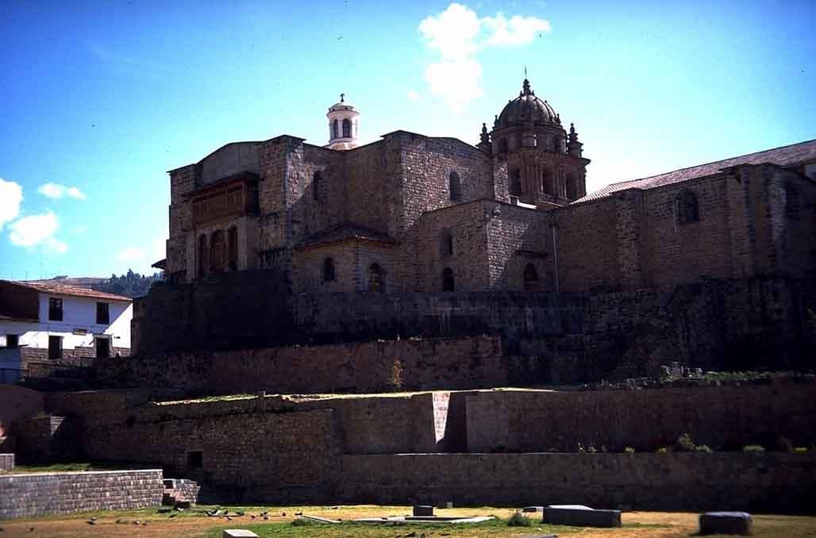

Caption: Spanish Santa Domingo Church built atop the Incan Coricancha (Temple of the Sun).
Source: This image from http://worldimages.sjsu.edu/Obj25538?sid=10237&x=3221369&port=163 is ©Kathleen Cohen and approved for free educational, non-profit use as found at the WorldImages Kiosk at California State University.

- Identify the source and type of document.

2. What is the message of the document?

- Does this document corroborate (support) or contradict the others? Why or why not?

4. How might this document help you answer the focus question?

Focus Question: To what extent did Spanish and native cultures blend in the New World?

Document 2: Christian Cross atop an Aztec Pyramid
After Spanish invaders defeated the Aztecs in the Mexican city of Tlatelolco in 1521, this ceramic plate was created showing a Christian cross atop an Aztec pyramid.

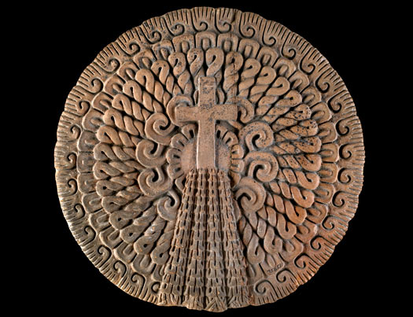

Caption: Ceramic piece showing Christian Cross atop an Aztec Temple.
Source: This image from the Chicago Field Museum online exhibit “The Aztec World” at http://www.fieldmuseum.org/aztecs/conclusion_1.asp is approved for free educational, non-profit use.

- Identify the source and type of document.

- What is the message of the document?

- Does this document corroborate (support) or contradict the others? Why or why not?

- How might this document help you answer the focus question?

Focus Question: To what extent did Spanish and native cultures blend in the New World?

Document 3: Aztec Ceramic Pitcher
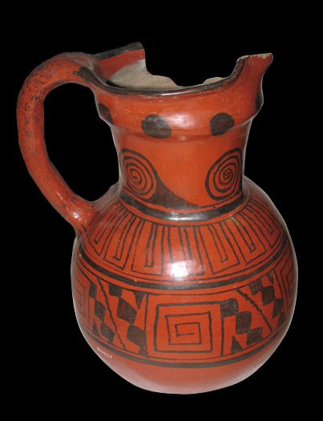
This ceramic drinking pitcher from colonial Mexico was made by an Aztec craftsman who included Spanish design and decoration.

Caption: Ceramic Aztec pitcher from the early 16h century colonial period.
Source: This image from the Chicago Field Museum online exhibit “The Aztec World” at http://www.fieldmuseum.org/aztecs/conclusion_1.asp is approved for free educational, non-profit use.

- Identify the source and type of document.

- What is the message of the document?

- Does this document corroborate (support) or contradict the others? Why or why not?

- How might this document help you answer the focus question?

Focus Question: To what extent did Spanish and native cultures blend in the New World?
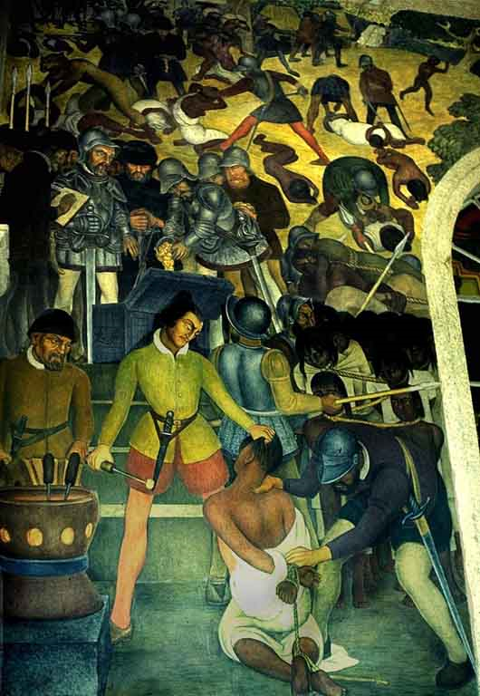
Document 4: Spaniards Branding Indians
Following the Spanish defeat of the Aztecs, Indian slaves were branded for identification and ordered to build new colonial buildings in the ruins of their ancient cities.

Caption: “Spaniards Branding Indians” by Diego Rivera, 1931.
Source: This image from http://worldimages.sjsu.edu/ VieO25575?sid=10237&x=3246023 is copyright Kathleen Cohen, free educational, non-profit use.

- Identify the source and type of document.

- What is the message of the document?

- How does the historical context influence the message of the document?

- Does this document corroborate (support) or contradict the others? Why or why not?

- How might this document help you answer the focus question?

Focus Question: To what extent did Spanish and native cultures blend in the New World?

Document 5: Spanish-American Grammar Guide
After Spanish officials decided that natives would be allowed to retain their native languages, grammar guides, such as the one shown here, were created to help religious teachers and leaders learn native languages.

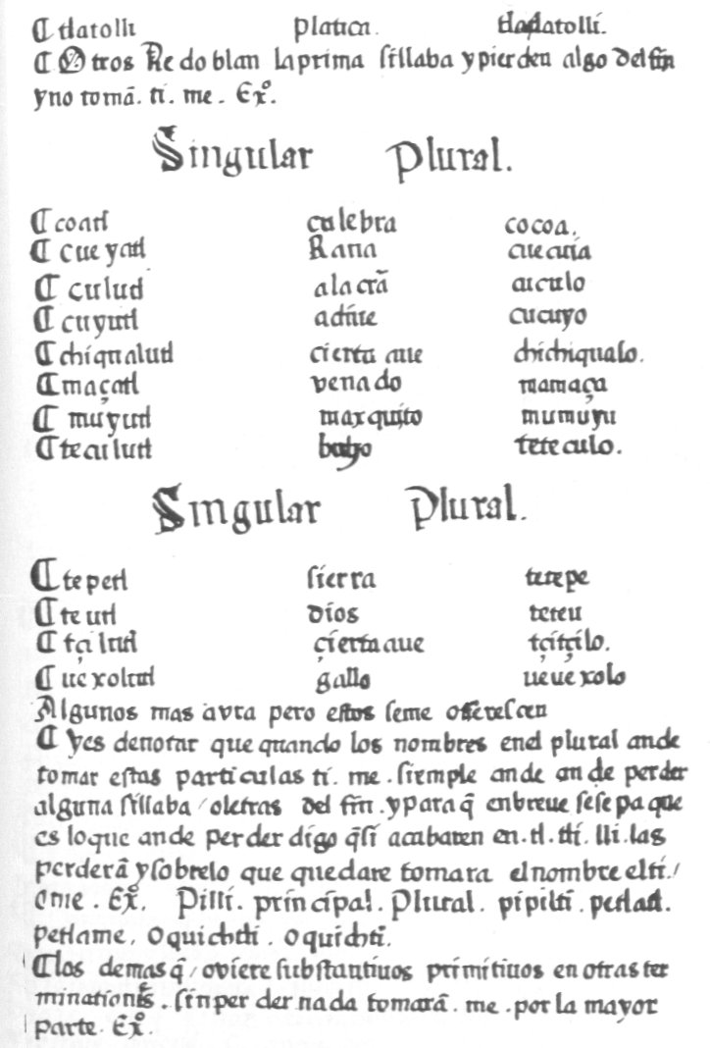
Caption: Page from Olmos' "Arte de la Lengua Mexicana", a grammar of the Nahuatl language, 1547.
Source: This image from http://en.wikipedia.org/wiki/Mesoamerican_languages is in the public
domain because its copyright has expired.

- Identify the source and type of document.

- What is the message of the document?

- Does this document corroborate (support) or contradict the others? Why or why not?

- How might this document help you answer the focus question?

Focus Question: To what extent did Spanish and native cultures blend in the New World?

Now, consider your responses to the questions as you viewed each of the documents about cultural blending in colonial Spanish America.
- Identify the source and type of document.
- What is the message of the document?
- How does the historical context influence the message of the document?
- Does this document corroborate (support) or contradict other ones? Why or why not?
- How might this document help you answer the focus question?

Answer the following question based on your review of documents 1 through 5.

To what extent did Spanish and native cultures blend in the New World?
- Think about the evidence that demonstrates the introduction of Spanish culture in the Americas.
- Think about the evidence that demonstrates the preservation of native culture in Spanish colonial life.
- Analyze the extent of Spanish and native cultural blending in the Americas.
- Include details and examples to support your answer.

