Historical Investigation — Impact of Labor Systems in the Americas


Directions: In order to answer the focus question, you must first consider the source, purpose, and content of each historical document. You must also consider how the content of each document corroborates (strengthens) or contradicts evidence found in other documents. Examine all the documents and then answer the questions that follow. This will assist you in answering the focus question at the end of the investigation.

Background: Colonial rule in the Americas was based on a racist system that limited the rights of indigenous and enslaved people and in many cases outlawed contact between blacks and whites. Systems of forced labor, including the plantation system, had a tremendous impact on the non-European people living in the Americas in places including the Caribbean, Brazil, South America, and North America. The labor systems imposed meant harsh conditions and few to no rights for indigenous and enslaved people in the Americas. Efforts to resist were mostly unsuccessful but some forms of resistance resulted in cultural blending that preserved elements of native and African culture.

Focus Question: How did labor systems impact indigenous and enslaved persons in the Americas?

Document 1: Restrictions on Slave Life, North America
The laws below were passed in North American colonies in response to slave resistance and rebellions, and out of fear of growing numbers of marriages and interracial children between Africans and Europeans. Most slave rebellions were not successful.

1662: Virginia law decreed that the children of slaves took on the status of their mother, in contrast to common law, which conferred the father’s status on a child. The law was intended to enslave the increasing number of children fathered by white men.

1663: Maryland legalized slavery and attempted to pass a law that would enslave free blacks and require that all blacks be slaves regardless of their mother’s status; in the following year, Maryland punished marriage between a white woman and a slave by requiring that she serve her husband’s master during her husband’s lifetime and that their children would be slaves.

1740: A year after the Stono Rebellion, South Carolina passed the Negro Act in 1740, which made it illegal for slaves to gather in groups, earn money, learn to read or raise food, and gave slave owners the right to kill rebellious slaves.

Source: This text from “Race: A Project of the American Anthropological Association: at http://www.understandingrace.org/history/gov/colonial_authority.html is reprinted under fair use guidelines, as defined as non-commercial educational purpose.

- Identify the source and type of document.

- What is the message of the document?

- Does this document corroborate (support) or contradict the others? Why or why not?

- How might this document help you answer the focus question?

Focus Question: How did labor systems impact indigenous and enslaved persons in the Americas?

Document 2: Church of La Compania Façade Decoration, Peru
The Spanish set out to deliberately destroy native culture in the Americas. They built buildings to show their power using Spanish styles of architecture. They deliberately built cathedrals on top of native sites of worship. The European style churches were meant to show the power of the Spanish, but the laborers who built them were natives.

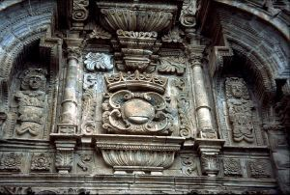

Source: This image from http://worldimages.sjsu.edu/Obj25549?sid=10237&x=4024019 is free for educational use.

- Identify the source and type of document.

- What is the message of the document?

- Does this document corroborate (support) or contradict the others? Why or why not?

- How might this document help you answer the focus question?

Focus Question: How did labor systems impact indigenous and enslaved persons in the Americas?

Document 3: Church Service at Plantation, South Carolina, 1863
Although many slaves were prohibited from meeting in groups on plantations due to the fear of organized rebellion, many were permitted to practice Christian religions.
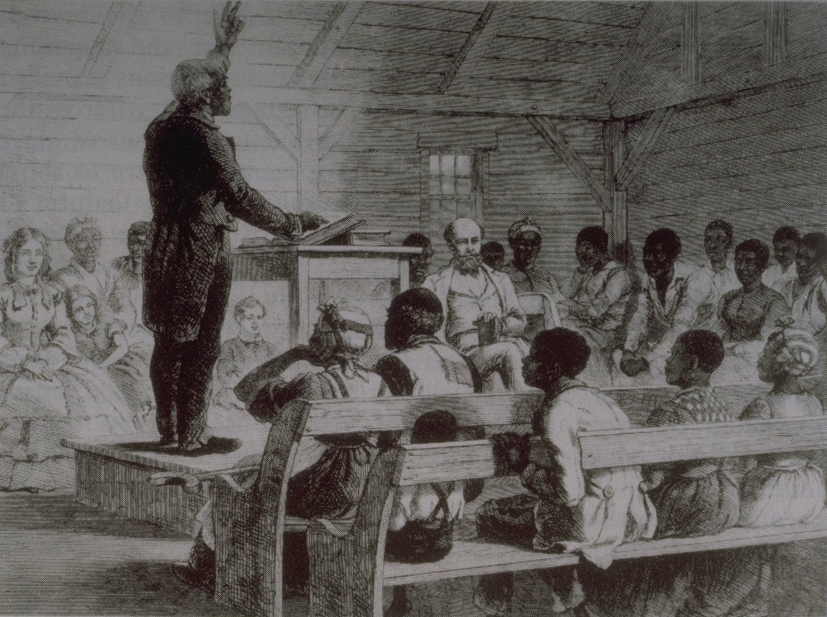

Source: "Church Service at Plantation, South Carolina, 1863”; Image Reference: NW0176, from The Illustrated London News (Dec. 5, 1863), vol. 43, p. 561. (Copy in Special Collections Department, University of Virginia Library) as shown on http://hitchcock.itc.virginia.edu/Slavery/details.php?categorynum=14&categoryName=Religion and Mortuary Practices&theRecord=25&recordCount=38.

- Identify the source and type of document.

- What is the message of the document?

- Does this document corroborate (support) or contradict the others? Why or why not?

- How might this document help you answer the focus question?

Focus Question: How did labor systems impact indigenous and enslaved persons in the Americas?

Document 4: Life in the Silver Mines in Potosí, Spanish America
The Spanish discovered large veins of silver in what is now Mexico and Peru by the mid- 1500s. Natives and enslaved Africans were forced to work in the mines. A Carmelite monk who travelled through Spanish America sometime between 1612 and 1620 wrote this excerpt. He described work in the silver mine of Potosí.

Continuing to Describe the Magnificence of the Potosí Range; and of the Indians There under Forced Labor (Mita) in Its Operations.

1652. According to His Majesty’s warrant, the mine owners on this massive range have a right to the mita of 13,300 Indians in the working and exploitation of the mines…

…After each has eaten his ration, they climb up the hill, each to his mine, and go in, staying there from that hour until Saturday evening without coming out of the mine; their wives bring them food, but they stay constantly underground, excavating and carrying out the ore from which they get the silver…

Source: Documents in World History, Volume 2, Peter N. Stearns, Stephen S. Gosch, and Erwin P. Grieshaber, Addison Wesley Longman, New York, 2000

- Identify the source and type of document.

- What is the message of the document?

- Does this document corroborate (support) or contradict the others? Why or why not?

- How might this document help you answer the focus question?

Focus Question: How did labor systems impact indigenous and enslaved persons in the Americas?

Document 5: Slavery in Brazil, Early 1800s
This painting was created by Jean-Baptiste Debret (1768-1848), a French painter who travelled to Brazil in 1816. He was part of a group of French artists sponsored by Portuguese King D. João who had moved to Rio to escape Napoleon.

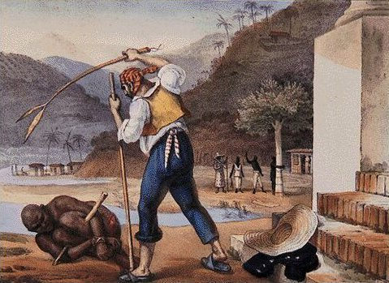

Source: This image from http://commons.wikimedia.org/wiki/File:024debret.jpg is in the public domain because its copyright has expired.

- Identify the source and type of document.

- What is the message of the document?

- Does this document corroborate (support) or contradict the others? Why or why not?

4. How might this document help you answer the focus question?

Focus Question: How did labor systems impact indigenous and enslaved persons in the Americas?

Document 6: Brazilian Slaves, 1820
European artist Henry Chamberlain created this painting. He was part of a group of European artists devoted to painting picturesque and landscape pictures.

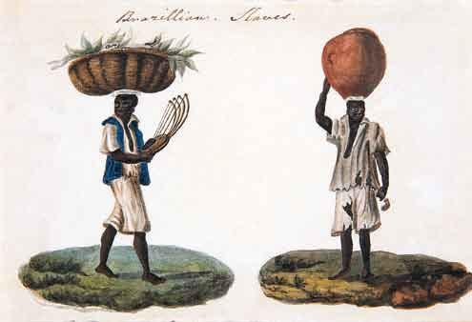

Source: This image from http://commons.wikimedia.org/wiki/File:Henry_Chamberlain_-_Escravos_brasileiros_II.JPG is in the public domain because its copyright has expired.

- Identify the source and type of document.

- What is the message of the document?

- Does this document corroborate (support) or contradict the others? Why or why not?

- How might this document help you answer the focus question?

Focus Question: How did labor systems impact indigenous and enslaved persons in the Americas?

Document 7: Life on a Sugar Plantation as Described by a Slave
Olauda Equiano was kidnapped at age 11, survived the Middle Passage and was enslaved on a sugar plantation in the West Indies. He was later sold to a Virginia planter. After ten years in slavery, he bought his freedom. At age 44, he published his autobiography, The Interesting Narrative of the Life of Olaudah Equiano, or Gustavus Vassa, the African. This is a short excerpt from that book.

It was very common in several of the islands, particularly in St. Kitts, for the slaves to be branded with the initial letters of their master’s name; and a load of heavy iron hooks hung about their necks. Indeed, on the most trifling occasions, they were loaded with chains; and often instruments of torture were added. The iron muzzle, thumb screws, etc., are so well known as not to need a description, and were sometimes applied for the slightest faults. I have seen a Negro beaten till some of his bones were broken, for only letting a pot boil over. Is it surprising that usage like this should drive the poor creatures to despair, and make them seek a refuge in death from those evils which render their lives intolerable?

Found in multiple sources, including google books: http://books.google.com/books?id=4GM6AAAAcAAJ&printsec=frontcover&dq=Olaudah+Equiano,+from+The+Interesting+Narrative+of+the+Life+of+Olaudah+Equiano,+or+Gustavus+Vassa,+the+African.&source=bl&ots=9SsLYQnZ6m&sig=ue2KgzfDNNq0OzazoKhklHCdRxo&hl=en&ei=v2ZYTfCDIsWblgeJy-mwBw&sa=X&oi=book_result&ct=result&resnum=6&ved=0CEgQ6AEwBQ#v=onepage&q&f=false

- Identify the source and type of document.

- What is the message of the document?

- Does this document corroborate (support) or contradict the others? Why or why not?

- How might this document help you answer the focus question?

Focus Question: How did labor systems impact indigenous and enslaved persons in the Americas?

Now, consider your responses to the questions as you viewed each of the documents about the impact of labor systems in the Americas.

- Identify the source and type of document.
- What is the message of the document?
- Does this document corroborate (support) or contradict other ones? Why or why not?
- How might this document help you answer the focus question?

Answer the following question based on your review of documents 1 through 7.

How did labor systems impact indigenous and enslaved persons in the Americas?
- Describe the working and living conditions of indigenous and enslaved persons in the Americas.
- How did indigenous and enslaved persons rebel against Europeans and preserve aspects of their cultures?
- Include details and examples to support your answer.

