Historical Investigation – England’s Glorious Revolution


Directions: In order to answer the focus question, you must first consider the source, purpose, and content of each historical document. You must also consider how the content of each document corroborates (strengthens) or contradicts evidence found in other documents. Examine all the documents and then answer the questions that follow. This will assist you in answering the focus question at the end of the investigation.
Focus Question: What led to the fall of absolute monarchies in England?
Document 1: King Charles I the Absolute Monarch
King Charles believed he was an absolute monarch who was said to rule from divine right (his power to rule came from God). His wealth and class status was reflected in his appearance in the portrait shown below.
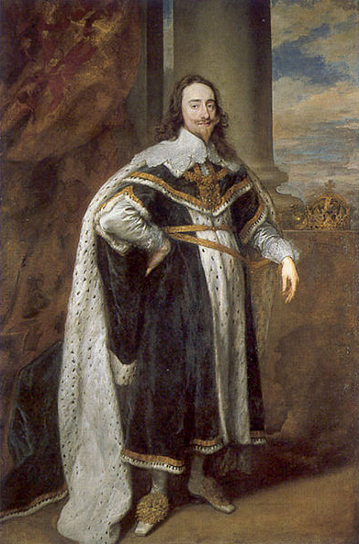
Source: This image from http://en.wikipedia.org/wiki/File:King_Charles_I_by_Antoon_van_Dyck.jpg is in the public domain because its copyright has expired.

- Identify the source and type of document.

- What is the message of the document?

- Does this document corroborate (support) or contradict the others? Why or why not?

- How might this document help you answer the focus question?

Focus Question: What led to the fall of absolute monarchies in England?
Document 2: The Cost of Absolute Rule
Absolute monarchs also used the money they raised from high taxes to pay for expansion of their empires, as shown in the map below. Spending expensive projects angered peasants and nobles and increased tension with competing European nations.
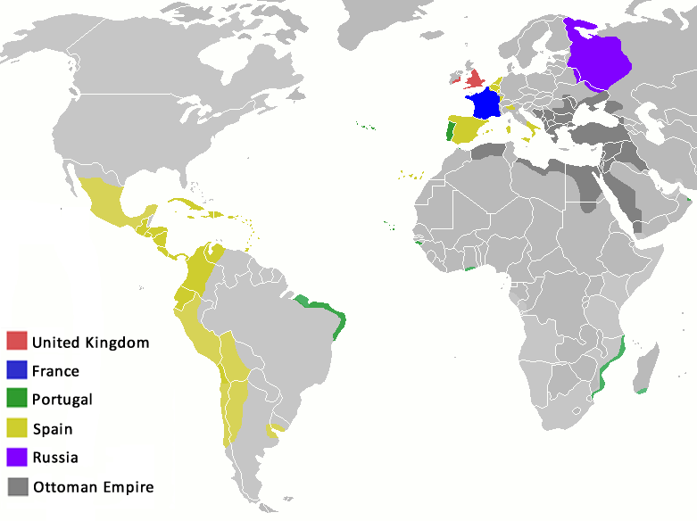
Source: This image from http://commons.wikimedia.org/wiki/File:Colonisation_1550.png is in the public domain.

- Identify the source and type of document.

- What is the message of the document?

- Does this document corroborate (support) or contradict the others? Why or why not?

- How might this document help you answer the focus question?

Focus Question: What led to the fall of absolute monarchies in England?
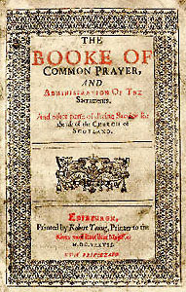
Document 3: Absolute Religious Rule
Earlier events of the Christian Reformations had divided the English kingdom (Scotland, Ireland, and England). Scotland was mainly Presbyterian and Puritan, Ireland mainly Catholic, and England mainly Anglican. Charles I wanted to unite the kingdom under the Anglican Church, and demanded that Scotland use only the book pictured here for prayer.

Source: This image from
http://upload.wikimedia.org/wikipedia/ en/e/e6/Book_of_common_prayer_Scotland_1637.jpg is in the public domain because its copyright has expired.

- Identify the source and type of document.

- What is the message of the document?

- Does this document corroborate (support) or contradict the others? Why or why not?

- How might this document help you answer the focus question?

Focus Question: What led to the fall of absolute monarchies in England?
Document 4: Parliament’s Response
In 1628, Charles I asked Parliament to approve tax increases to fund war with Spain, but Parliament refused and, in return, the king dissolved Parliament. Unable to tax the English people, Charles began to charge fees and allow English soldiers to stay in citizens’ homes. Parliament responded by passing the Petition of Right to limit the king’s ability to do things such as fine and tax without Parliament’s permission, thereby creating the first “limited government.”

Petition of Right
To the King's Most Excellent Majesty, …it is declared and enacted, that from thenceforth no person should be compelled to make any loans to the king against his will, because such loans were against reason… your subjects have inherited this freedom, that they should not be compelled to contribute to any tax, tallage, aid, or other like charge not set by common consent, in parliament.

Source: http://odur.let.rug.nl/~usa/D/1601-1650/england/por.htm

- Identify the source and type of document.

- What is the message of the document?

- Does this document corroborate (support) or contradict the others? Why or why not?

- How might this document help you answer the focus question?

Focus Question: What led to the fall of absolute monarchies in England?
Document 5: Beheading of King Charles I of England
This print depicts the beheading of King Charles I, an English monarch who ruled from 1625 until his death in 1649. The beheading was a public execution that many believed meant the end of absolute monarchy.

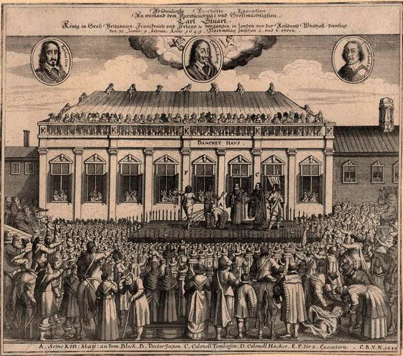
Source: This image from http://en.wikipedia.org/wiki/File:Contemporary_German_print_depicting_Charles_Is_beheading.jpg is in the public domain because its copyright has expired.

- Identify the source and type of document.

- What is the message of the document?

- Does this document corroborate (support) or contradict the others? Why or why not?

- How might this document help you answer the focus question?

Focus Question: What led to the fall of absolute monarchies in England?
Now, consider your responses to the questions as you viewed each of the documents about the fall of absolute monarchies in England.
- Identify the source and type of document.
- What is the message of the document?
- Does this document corroborate (support) or contradict the others? Why or why not?
- How might this document help you answer the focus question?

Answer the following question based on your review of documents 1 through 5.
What led to the fall of absolute monarchies in England?
- Think about how the events leading up to the Glorious Revolution challenged the power of absolute monarchs.
- Think about how the Glorious Revolution replaced absolutism with limited government and parliamentary monarchs.
- Include details and examples to support your answer.

