Historical Investigation — A French Revolution


Directions: In order to answer the focus question, you must first consider the source, purpose, and content of each historical document. You must also consider how the content of each document corroborates (strengthens) or contradicts evidence found in other documents. Examine all the documents and then answer the questions that follow. This will assist you in answering the focus question at the end of the investigation.

Focus Question: Was the French Revolution a success?

Document 1: Women March on Versailles
Below is an engraving of the women’s march on Versailles, the palace of the French king. They demanded aid to help recover from soaring bread prices and low wages. When King Louis XVI failed to respond, the women stormed the palace, killing several guards. The fighting ended when the King agreed to leave Versailles and to recognize the authority of the National Assembly. The women of France had forced King Louis XVI to openly support the government formed by the Third Estate.
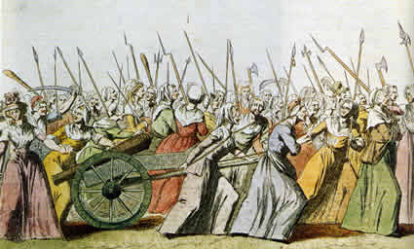

Caption: An illustration of the Women’s March on Versailles, 5 October 1789.
Source: This image from http://en.wikipedia.org/wiki/File:Women%27s_March_on_Versailles.jpg is in the public domain because its copyright has expired.

- Identify the source and type of document.

- What is the message of the document?

- Does this document corroborate (support) or contradict the others? Why or why not?

- How might this document help you answer the focus question?

Focus Question: Was the French Revolution a success?

Document 2: The Declaration of the Rights of Man
In 1789, the National Assembly passed the Declaration of the Rights of Man. This document reversed the social order of the estate system established by the Old Regime by instituting many of the ideals of enlightenment thinkers. Two years after its publication, a new French government was established, a constitutional monarchy, with most power lying with a Legislative Assembly elected by the people, and additional power granted to the King, who maintained the right to veto laws passed by the Assembly.
Approved by the National Assembly of France, August 26, 1789
The representatives of the French people, organized as a National Assembly, believing that the ignorance, neglect, or contempt of the rights of man are the sole cause of public calamities and of the corruption of governments, have determined to set forth in a solemn declaration the natural, unalienable, and sacred rights of man,
1. Men are born and remain free and equal in rights. Social distinctions may be founded only upon the general good.
2. The aim of all political association is the preservation of the natural and imprescriptible [cannot be taken away] rights of man. These rights are liberty, property, security, and resistance to oppression.
7. No person shall be accused, arrested, or imprisoned except in the cases and according to the forms prescribed by law.

9. As all persons are held innocent until they shall have been declared guilty, if arrest shall be deemed indispensable, all harshness not essential to the securing of the prisoner's person shall be severely repressed by law.
National Assembly, 1789

Source: http://avalon.law.yale.edu/18th_century/rightsof.asp
- Identify the source and type of document.

- What is the message of the document?

- Does this document corroborate (support) or contradict the others? Why or why not?

- How might this document help you answer the focus question?

Focus Question: Was the French Revolution a success?

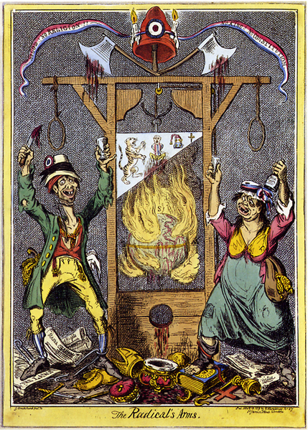
Document 3: Reign of Terror
The period after the constitutional monarchy, from 1792-1795, became known simply as the “Reign of Terror.” It began when King Louis XVI attempted to flee the country and was accused of attempting an overthrow of the new government. The constitutional monarchy fell apart. Louis XVI was executed, and so too was the queen, Marie Antoinette. In fact, any person suspected of opposing the French revolution or supporting the monarchy, was executed. Estimates of as many of 40,000 executions took place during this three year period- most without a trial. Here, a British cartoonist, George Cruikshank, depicts the events of the Reign of Terror in an 1819 cartoon.

Caption: French Radicals of the 3rd Estate are depicted at the guillotine, a device used to behead enemies, during the Reign of Terror.

Source: This image from http://en.wikipedia.org/wiki/File:Cruikshank_-_The_Radical%27s_Arms.png is in the public domain because its copyright has expired.
- Identify the source and type of document.

- What is the message of the document?

- Does this document corroborate (support) or contradict the others? Why or why not?

- How might this document help you answer the focus question?

Focus Question: Was the French Revolution a success?

Document 4: Execution of Robespierre
The Reign of Terror ended when its leader, Maximilien Robespierre, also lost the support of the people. Seeing the Catholic Church as a major source of inequality in the old government, Robespierre attempted to completely eliminate its influence. But when the Robespierre government tried to tell people what kind of God they could worship, and on what days they were free to do so, many Catholic peasants became upset. Along with growing suspicion that Robespierre executed people with little or no reason, enough popular support existed to oust Robespierre. Together with many other leaders in his government, Robespierre faced the same fate he had forced on so many others: execution.
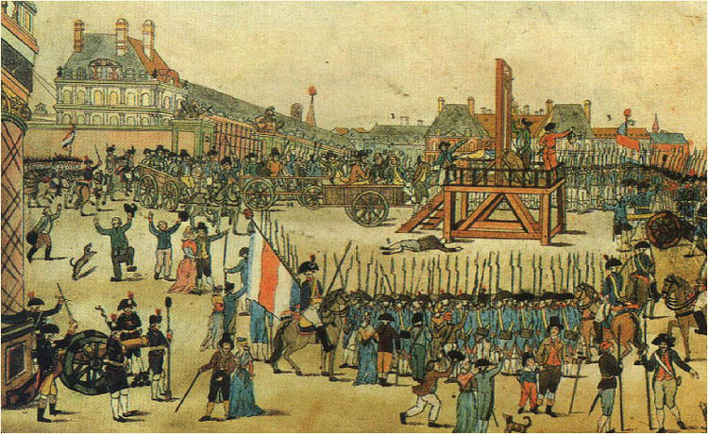
Caption: Robespierre was executed at the guillotine in 1794
Source: This image from http://en.wikipedia.org/wiki/File:Execution_robespierre,_saint_just....jpg is in the public domain because its copyright has expired.
- Identify the source and type of document.

- What is the message of the document?

- Does this document corroborate (support) or contradict the others? Why or why not?

- How might this document help you answer the focus question?

Focus Question: Was the French Revolution a success?

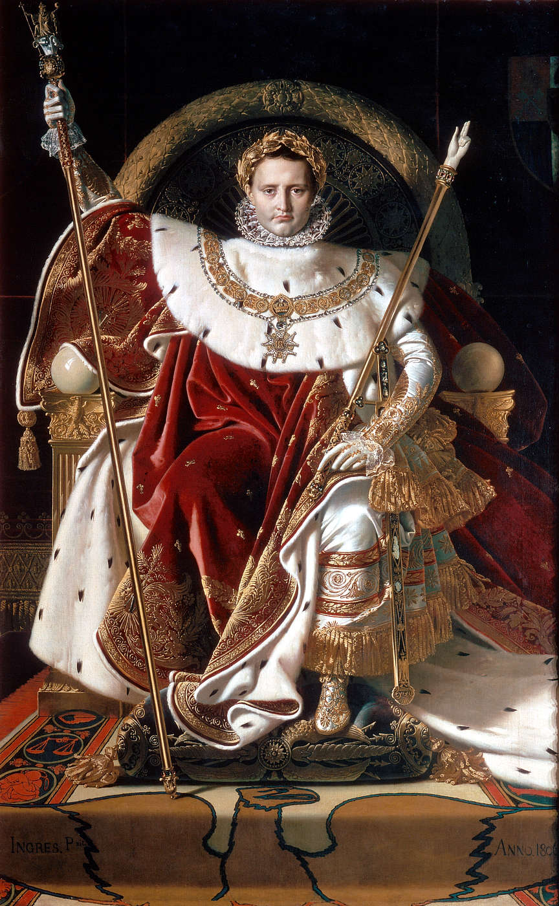
Document 5: The Imperial Throne
Artist, Jean Auguste Dominque Ingres, created this artwork of the new Emperor of France Napoleon Bonoparte, in 1806. Tired of terror created in the wake of the Revolution, the people supported Napoleon in an initial power sharing structure developed in 1799. But Napoleon declared himself Emperor of France in 1804. He became known for his military conquests abroad and establishing and spreading the Napoleonic Code.

Caption: Napoleon Bonaparte on the imperial throne of France, 1806.

Source: This image from http://en.wikipedia.org/wiki/File: Ingres,_Napoleon_on_his_Imperial_throne.jpg is in the public domain because its copyright has expired.

- Identify the source and type of document.

- What is the message of the document?

- Does this document corroborate (support) or contradict the others? Why or why not?

- How might this document help you answer the focus question?

Focus Question: Was the French Revolution a success?

Now, consider your responses to the questions as you viewed each of the documents about the French Revolution.
- Identify the source and type of document.
- What is the message of the document?
- Does this document corroborate (support) or contradict other ones? Why or why not?
- How might this document help you answer the focus question?

Answer the following question based on your review of documents 1 through 5.

Was the French Revolution a success?
- Think about the evidence that demonstrates the French Revolution was a success.
- Think about the evidence that demonstrates the French Revolution was not a success.
- Think about which evidence is more convincing.
- Include details and examples to support your answer.

