Historical Investigation — Japan Shows Its Strength


Directions: In order to answer the focus question, you must first consider the source, purpose, and content of each historical document. You must also consider how the content of each document corroborates (strengthens) or contradicts evidence found in other documents. Examine all the documents and then answer the questions that follow. This will assist you in answering the focus question at the end of the investigation.

Focus Question: How did Japanese efforts to demonstrate its strength in the world impact Japan and its neighbors?

Document 1: Map of Sino-Japanese War Battles (1894-1895)
The Chinese (Sino) and Japanese went to war in 1894. The map below shows some of the major battles that took place between these two countries.
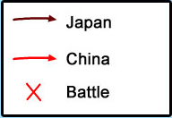
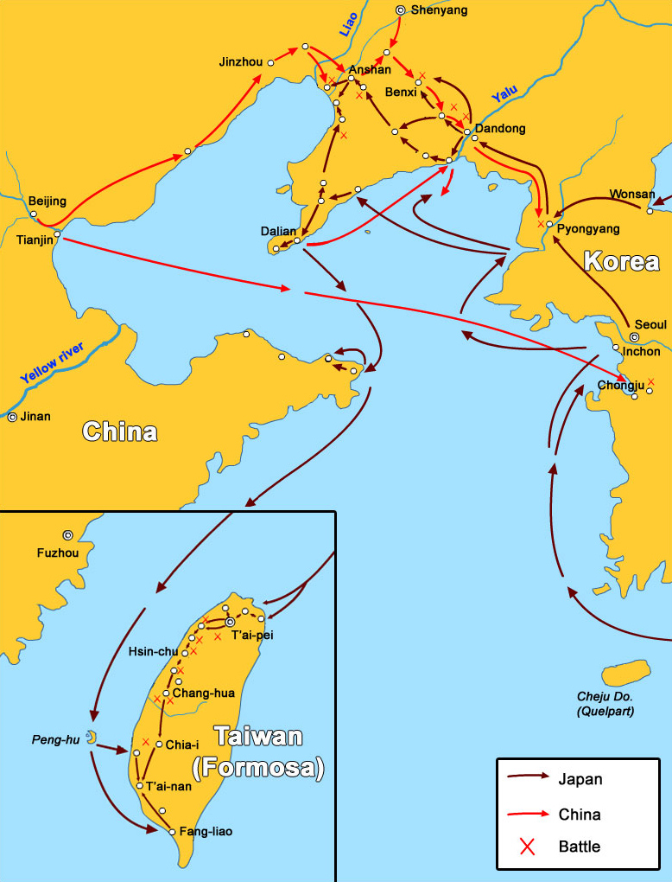

Source: This image from http://en.wikipedia.org/wiki/File:First_Chinese_Japanese_war_map_of_battles.jpg is licensed under the terms of the GNU Free Documentation License.

- Identify the source and type of document.

- What patterns do you see on this document?

- Does this document corroborate (support) or contradict the others? Why or why not?

- How might this document help you answer the focus question?

Focus Question: How did Japanese efforts to demonstrate its strength in the world impact Japan and its neighbors?

Document 2: British Cartoon Depicting the Sino-Japanese War

In 1895, the Sino-Japanese War between China and Japan ended. This cartoon was published in a British magazine and it depicts the end of the war.

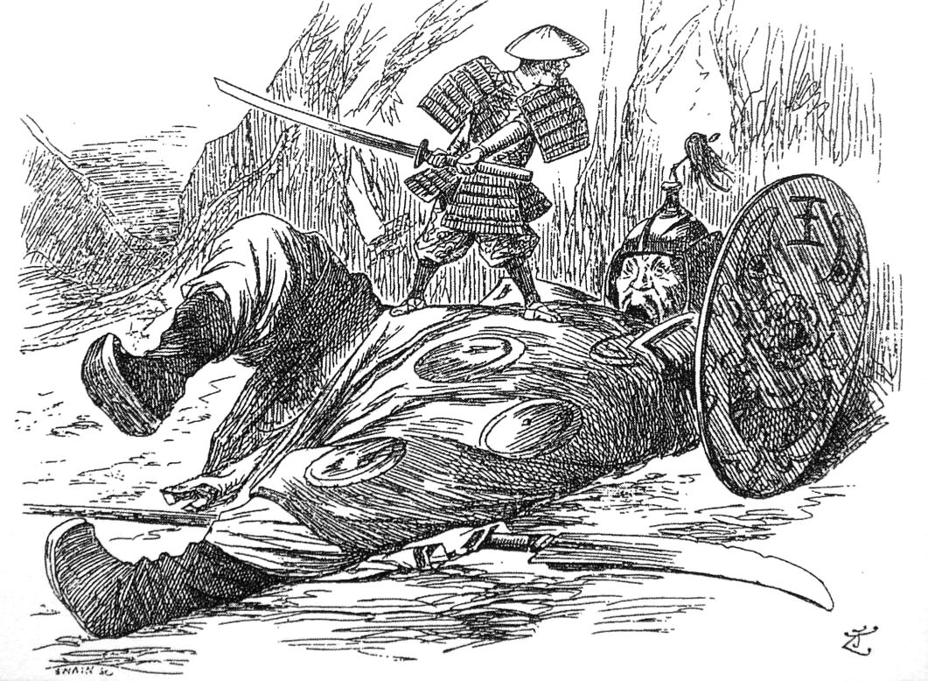

Source: This image from http://en.wikipedia.org/wiki/File:JapanPunch29September1894.jpg is in the public domain because its copyright has expired.

- Identify the source and type of document.

- What is the message of the document?

- Does this document corroborate (support) or contradict the others? Why or why not?

- How might this document help you answer the focus question?

Focus Question: How did Japanese efforts to demonstrate its strength in the world impact Japan and its neighbors?

Document 3: Treaty of Portsmouth, 1905
The Russo-Japanese War ended in 1905 with the signing of the Treaty of Portsmouth. Below are selections from the treaty.

ARTICLE II.
The Imperial Russian Government, acknowledging that Japan possesses in Korea paramount political, military and economical interests engages neither to obstruct nor interfere with measures for guidance, protection and control which the Imperial Government of Japan may find necessary to take in Korea…

ARTICLE III.
Japan and Russia mutually engage to restore entirely and completely to the exclusive administration of China all portions of Manchuria now in occupation, or under the control of the Japanese or Russian troops, with the exception of the territory above mentioned.
ARTICLE VI.
The Imperial Russian Government engages to transfer and assign to the Imperial Government of Japan, without compensation and with the consent of the Chinese Government, the railway between Chang-chunfu and Kuanchangtsu and Port Arthur, and all the branches, together with all the rights, privileges and properties appertaining thereto in that region, as well as all the coal mines in said region belonging to or worked for the benefit of the railway.

Source: http://www.russojapanesewar.com/top.html

- Identify the source and type of document.

- What is the message of the document?

- Does this document corroborate (support) or contradict the others? Why or why not?

- How might this document help you answer the focus question?

Focus Question: How did Japanese efforts to demonstrate its strength in the world impact Japan and its neighbors?

Document 4: Treaty of Annexation, 1910
In 1910, Japan officially annexed Korea. Below is part of the treaty of this annexation.

In order to maintain peace and stability in Korea, to promote the prosperity and welfare of Koreans, and at the same time to ensure the safety and repose of foreign residents, it has been made abundantly clear that fundamental changes in the actual regime of government are absolutely essential. The Governments of Japan and Korea, being convinced of the urgent necessity of introducing reforms responsive to the requirements of the situation and of furnishing sufficient guarantee for the future, have, with the approval of His Majesty the Emperor of Japan and His Majesty the Emperor of Korea, concluded, through their plenipotentiaries, a treaty providing for complete annexation of Korea to the Empire of Japan. By virtue of that important act, which shall take effect on its promulgation on August 29, 1910, the Imperial Government of Japan shall undertake the entire government and administration of Korea…

Source: http://www.international.ucla.edu/eas/documents/kore1910.htm

- Identify the source and type of document.

- What is the message of the document?

- Does this document corroborate (support) or contradict the others? Why or why not?

- How might this document help you answer the focus question?

Focus Question: How did Japanese efforts to demonstrate its strength in the world impact Japan and its neighbors?

Document 5: Japanese Imperialism Leads to War, 1931
From the late 19th centuries through the beginning of World War II, Japan sought to spread its influence. Below is a map of Asia in 1931 with the dates of Japanese colonization.

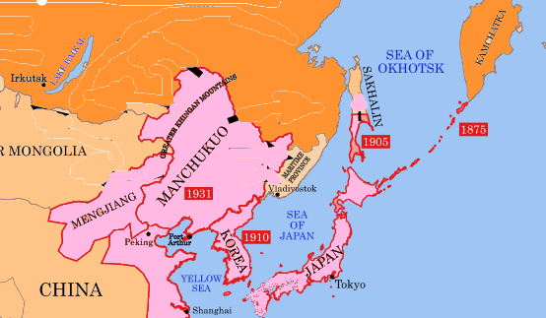Source: This image from http://commons.wikimedia.org/wiki/File:Hokushin-ron-Map.svg has been altered and is licensed with Creative Commons Attribution. Attribution: Pacific_Area_-_The_Imperial_Powers_1939_-_Map.jpg and modifications by Begoon.

- Identify the source and type of document.

- What is the message of the document?

- Does this document corroborate (support) or contradict the others? Why or why not?

- How might this document help you answer the focus question?

Focus Question: How did Japanese efforts to demonstrate its strength in the world impact Japan and its neighbors?

Now, consider your responses to the questions as you viewed each of the documents about Japanese strength.
- Identify the source and type of document.
- What is the message of the document?
- Does this document corroborate (support) or contradict the others? Why or why not?
- How might this document help you answer the focus question?

Answer the following question based on your review of documents 1 through 5.

How did Japanese efforts to demonstrate its strength in the world impact Japan and its neighbors?
- Think about how Japanese actions affected its neighbors.
- Draw conclusions as to how these actions impacted Japan.
- Include details and examples to support your answer.

