Historical Investigation — The Crimean War


Directions: In order to answer the focus question, you must first consider the source, purpose, and content of each historical document. You must also consider how the content of each document corroborates (strengthens) or contradicts evidence found in other documents. Examine all the documents and then answer the questions that follow. This will assist you in answering the focus question at the end of the investigation.

Focus Question: What were the causes and effects of the Crimean War?

Document 1: Chart of Russo-Turkish (Ottoman) Conflicts

Name and Date of Conflict | Victor(s)
Russo-Turkish War (1568 – 1570) | Russian victory
Russo-Turkish War (1571 – 1574) | Draw – both sides had victories and losses; no declared victor
Russo-Turkish War (1686 – 1700) | Russian victory
Russo-Turkish War (1710 – 1711) | Ottoman victory
Russo-Austrian-Turkish War (1735 – 1739) | Draw at Russian front; Austrian defeat
Russo-Turkish War (1768 – 1774) | Russian victory
Russo-Turkish War (1787 – 1792) | Russian victory
Russo-Turkish War (1806 – 1812) | Russian victory
Russo-Turkish War (1828 – 1829) | Russian victory
Crimean War (1853 – 1856) | Ottoman, French, and British victory
Russo-Turkish War (1877 – 1878) | Russian, Bulgarian, Romanian, Serbian, and Montenegrin victory
World War I: Caucasus Campaign (1914 – 1918) | Ottoman and Russian Empires defeated and ultimately collapse

Source: http://en.wikipedia.org/wiki/History_of_the_Russo-Turkish_wars

- Identify the source and type of document.

- What patterns do you see emerging from this document?

- Does this document corroborate (support) or contradict the others? Why or why not?

- How might this document help you answer the focus question?

Focus Question: What were the causes and effects of the Crimean War?

Document 2: Website Description of the Crimean War
This is from an introduction to a website called A Web of English History. It is maintained by Dr. Marjorie Bloy, a professor of history.

Although the long term causes of the Crimean War probably were more crucial, the immediate causes of the war - ostensibly, at least - were over religion, particularly over the protectorship of the Holy Places in Jerusalem. The Holy Land was part of the Muslim Ottoman Empire but also was the home of Judaism and Christianity. In the Middle Ages, Christian Europe and the Muslim east had fought the Crusades over control of this land. However, the Christian Church was divided into numerous small denominations. The Eastern Orthodox Church and Roman Catholic Church were the two major branches of Christianity. Unfortunately, these main denominations could not work together. Both of them wanted to control the Holy Places.

Source: http://www.historyhome.co.uk/forpol/crimea/immcauses.htm

- Identify the source and type of document.

- What is the message of the document?

- Does this document corroborate (support) or contradict the others? Why or why not?

- How might this document help you answer the focus question?

Focus Question: What were the causes and effects of the Crimean War?

Document 3: British Royal Navy Bombards Solovetsky during the Crimean War (1868)

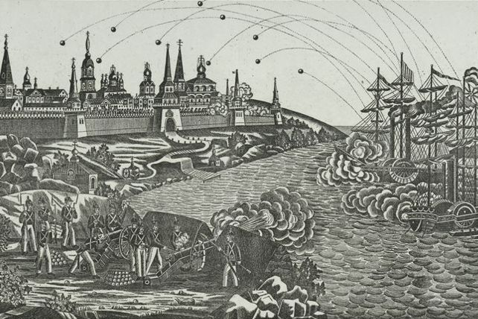
Caption: Bombardment of the Solovetsky Monastery in the White Sea by the Royal Navy during the Crimean War.
Source: This image from http://en.wikipedia.org/wiki/File:Napadka.jpg is in the public domain.

- Identify the source and type of document. How reliable is this source?

- What is the message of the document?

- Does this document corroborate (support) or contradict the others? Why or why not?

- How might this document help you answer the focus question?

Focus Question: What were the causes and effects of the Crimean War?

Document 4: Map of Crimean Region, 1856
The maps show the Balkan area before and after the Treaty of Paris that ended the Crimean War. The lightest green areas of Wallachia and Moldavia in the second map became independent of Russian rule.
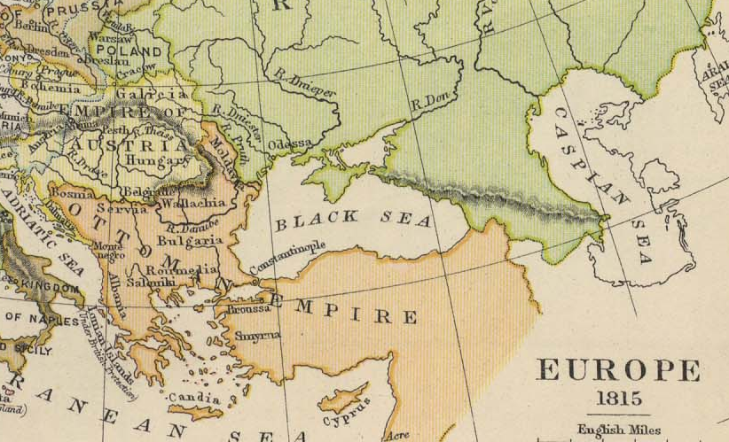
Caption: Map of the Balkan Area in 1815, before the Treaty of Paris
Source: This image from http://www.lib.utexas.edu/maps/historical/europe1815_1905.jpg is in the public domain.

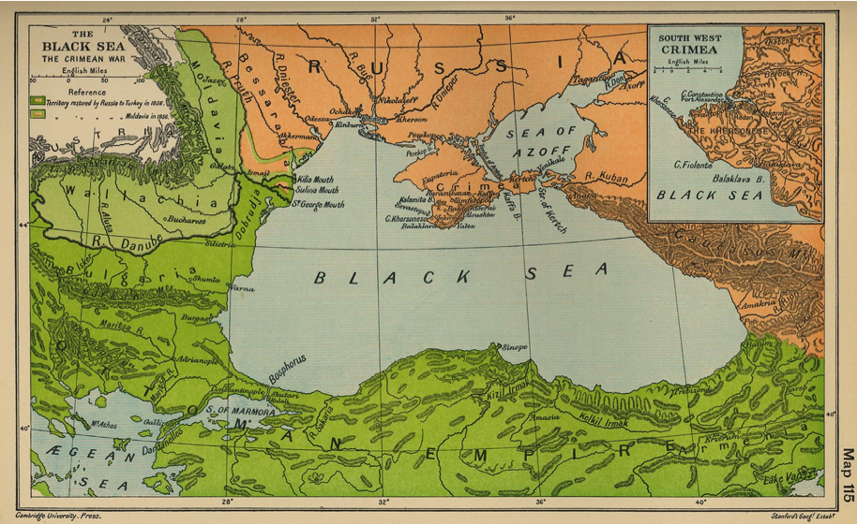
Caption: Map of the Balkan Area in 1856, after the Treaty of Paris
Source: This image from http://en.wikipedia.org/wiki/File:Black_sea_crimean_war.jpg is in the public domain.

- Identify the source and type of document.

- What is the message of the document?

- Does this document corroborate (support) or contradict the others? Why or why not?

- How might this document help you answer the focus question?

Focus Question: What were the causes and effects of the Crimean War?

Document 5: Letter to Dr. William Bowman (1854) by Florence Nightingale
Florence Nightingale was a nurse who tended sick and wounded soldiers at the front in the Crimean War. She established a nursing school in London and set the foundations for professional nursing standards. In this letter she reports on the sanitary conditions she found while tending to the wounded during the Crimean War. Each year, International Red Cross Day is held on her birthday.

We have no room for corpses in the wards…The next poor fellow has two stumps for arms – and the next has lost an arm and leg…Not a sponge, nor a rag of linen, not anything have I left. Everything is gone to make slings and stump pillows and shirts. These poor fellows have not had a clean shirt nor been washed for two months before they came here, and the state in which they arrive from the transport is literally crawling. I hope in a few days we shall establish a little cleanliness. But we have not a basis nor a towel nor a bit of saop nor a broom – I have ordered 300 scrubbing brushes…But, anyway, among these exhausted frames the mortality of the operations is frightful.

Source: I Have Done my Duty: Florence Nightingale in the Crimean War. University of Iowa Press (1987).

- Identify the source and type of document.

- What is the message of the document?

- Does this document corroborate (support) or contradict the others? Why or why not?

4. How might this document help you answer the focus question?

Focus Question: What were the causes and effects of the Crimean War?
Now, consider your responses to the questions as you viewed each of the documents about the causes and effects of the Crimean War.
- Identify the source and type of document.
- What is the message of the document?
- Does this document corroborate (support) or contradict the others? Why or why not?
- How might this document help you answer the focus question?

Answer the following question based on your review of documents 1 through 5.

What were the causes and effects of the Crimean War?
- Think about the long-term and short-term causes of the war.
- Draw conclusions about long-term effects of the war.
- Include details and examples to support your answer.

