Historical Investigation —Bismarck and German Unification


Directions: In order to answer the focus question, you must first consider the source, purpose, and content of each historical document. You must also consider how the content of each document corroborates (strengthens) or contradicts evidence found in other documents. Examine all the documents and then answer the questions that follow. This will assist you in answering the focus question at the end of the investigation.

Focus Question: How important was the role of Otto Von Bismarck in the creation of a German nation-state?

Document 1: The Proclamation of the German Empire
Anton Alexander von Werner was a German painter and tutor to German Emperor William II. The painting below shows the proclamation of the German Empire in the Palace of Versailles. Bismarck appears in the center in white. Under Bismarck, Prussia attacked and defeated Austria in 1866 and France in 1870. With both wars, Bismarck added territory to the German Confederation.

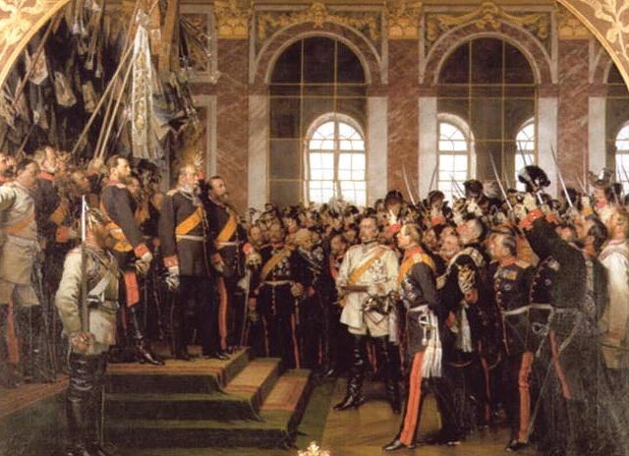
Painting by Anton von Werner, 1885

Source: This image from http://en.wikipedia.org/wiki/File:Reichsgr%C3%BCndung1871-AW.jpg is in the public domain.

- Identify the source and type of document.

- What is the message of the document?

- How does the historical context influence the message of the document?

- Does this document corroborate (support) or contradict the others? Why or why not?

- How might this document help you answer the focus question?

Focus Question: How important was the role of Otto Von Bismarck in the creation of a German nation-state?

Document 2: “Dropping the Pilot” Political Cartoon
Sir John Tenniel was an English illustrator and satirical artist. The following cartoon was a commentary on the forced resignation of Otto von Bismarck from the government of Emperor William II of Germany in 1890.

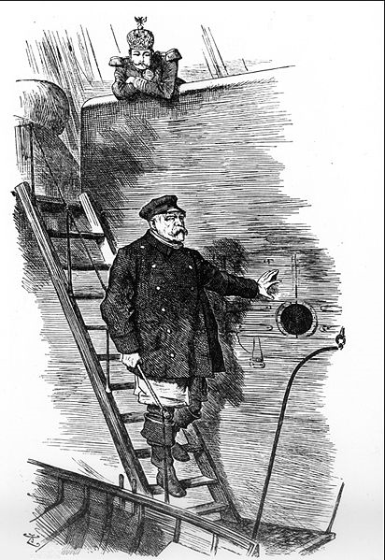

Source: This image from http://en.wikipedia.org/wiki/File:1890_Bismarcks_Ruecktritt.jpg is in the public domain.

- Identify the source and type of document.

- What is the message of the document?

- How does the historical context influence the message of the document?

- Does this document corroborate (support) or contradict the others? Why or why not?

- How might this document help you answer the focus question?

Focus Question: How important was the role of Otto Von Bismarck in the creation of a German nation-state?

Document 3: A Historian’s View on Bismarck
Norman Rich is a writer on political and social history. Below is an excerpt from his book The Age of Nationalism and Reform, 1850–1890, which examines the spread of nationalism across the European continent beginning in 1850.

Bismarck was an artist in statecraft as Napoleon had been an artist in war. Like Napoleon’s campaign strategy, Bismarck’s policy was never bound by fixed rules or preconceptions. While remaining aware of long-term goals and broad perspectives, he concentrated on the exigencies [needs] of the moment. . . . He did not only take into account the most obvious moves of his opponents; he was prepared to deal with every conceivable move, even the most stupid, which if unanticipated might upset the cleverest calculations. Much of his success depended on patience and timing…Bismarck’s outstanding quality, and the one he himself valued most highly in a statesman, was the ability to choose the most opportune and least dangerous political course.

Source: The Age of Nationalism and Reform, 1850–1890, by Norman Rich (W.W. Norton, 1977)

- Identify the source and type of document.

- What is the message of the document?

- Does this document corroborate (support) or contradict the others? Why or why not?

- How might this document help you answer the focus question?

Focus Question: How important was the role of Otto Von Bismarck in the creation of a German nation-state?

Document 4: A Historian’s View on Bismarck
L.C.B. Seaman is a writer on political and social history. Below is an excerpt from his book Vienna to Versailles, which examines events in Europe from 1815-1920.

...The second interpretation which should be abandoned is that Bismarck planned the events of the sixties in advance, and that when he planned them the results were always what he had intended. . . This view of Bismarck as the dynamic ruthless realist planning the whole of this campaign brilliantly and wickedly in advance is based not on the facts but on a legend; a legend created by Bismarck to minister to his own vanity as an individual and to the cause of his indispensability as a politician.

Source: Vienna to Versailles, by L.C.B. Seaman (Methuen, 1955; Harper & Row, 1963)

- Identify the source and type of document.

- What is the message of the document?

- Does this document corroborate (support) or contradict the others? Why or why not?

- How might this document help you answer the focus question?

Focus Question: How important was the role of Otto Von Bismarck in the creation of a German nation-state?

Document 5: The German's Fatherland
Born and raised in Sweden, Ernst Moritz Arndt studied history and theology. In 1801, he accepted a teaching position at the University in Greifswald, Germany. His poem of 1813, "The German's Fatherland", was written directly after the defeat of Napoleon's armies and the collapse of Napoleonic rule in Central Europe--more than fifty years before the official unification of Germany. It was set to music and sung countless times by German nationalists in the nineteenth century. The poem established language and culture, as well as hatred of the French, as a basis for the nation-state.
Which is the German’s fatherland?
Is’t Prussia’s or Swabia’s land?
Is’t where the Rhine’s rich vintage streams?
Or where the Northern sea-gull screams?—
Ah, no, no, no!
His fatherland’s not bounded so!...

Which is the German’s fatherland?
So tell me now at last the land!—
As far’s the Germans accent rings
And hymns to God in heaven sings,—
That is the land,—
There, brother, is thy fatherland!

There is the German’s fatherland,
Where oaths attest the grasped hand,—
Where truth beams from the sparkling eyes,
And in the heart love warmly lies;—
That is the land,—
There, brother, is thy fatherland!

That is the German’s fatherland,
Where wrath pursues the foreign band,—
Where every Frank is held a foe,
And Germans all as brothers glow;—
That is the Land,—
All Germany’s thy fatherland!
Poem by Ernst Moritz Arndt, 1813
Source: Ernst Moritz Arndt, “The German Fatherland,” in German History in Documents and Images, German Historical Institute, Washington, DC (www.germanhistorydocs.ghi-dc.org).

- Identify the source and type of document.

- What is the message of the document?

- How does the historical context influence the message of the document?

- Does this document corroborate (support) or contradict the others? Why or why not?

- How might this document help you answer the focus question?

Focus Question: How important was the role of Otto Von Bismarck in the creation of a German nation-state?

Document 6: Procession to Hambach Castle
In the south German states, restrictive measures against political expression, and increased tax burdens and tariffs, led to large political demonstrations, such as the Hambach Festival of 1832. Students and professionals dominated the crowd, with 30,000 people taking part. Speakers and demonstrators called for a German nation-state and denounced Germany's princes and their confederation.

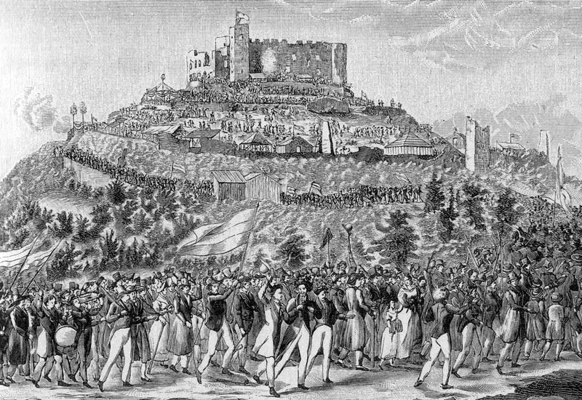

Source: This image from http://en.wikipedia.org/wiki/File:800px-Zug-zum-hambacher-schloss_1-1200x825.jpg is in the public domain.

- Identify the source and type of document.

- What is the message of the document?

- How does the historical context influence the message of the document?

- Does this document corroborate (support) or contradict the others? Why or why not?

5. How might this document help you answer the focus question?

Focus Question: How important was the role of Otto Von Bismarck in the creation of a German nation-state?

Now, consider your responses to the questions as you viewed each of the documents about German unification.
- Identify the source and type of document.
- What is the message of the document?
- How does the historical context influence the message of the document?
- Does this document corroborate (support) or contradict the others? Why or why not?
- How might this document help you answer the focus question?

Answer the following question based on your review of documents 1 through 6.

How important was the role of Otto Von Bismarck in the creation of a German nation-state?
- Think about the factors and characteristics present that promoted nationalism.
- Think about which sources were most credible and how context and perspective might influence the sources.
- Analyze how Otto Von Bismarck supported the rise of nationalism and unification.
- Include details and examples to support your answer.

